User Guide

jWebSocket
jWebSocket Management Desk
1.0

Author?

- Solution Characteristics
jWebSocket Management Desk tool is a web solution that allows dynamic maintenance of applications developed with jWebSocket framework. This tool provides the possibility to update the code and the application settings as well as add or remove functionalities at runtime. jWebSocket Management Desk offers a dynamic maintenance without affecting the architecture of the programs that are updated, is a user-friendly tool, it is multiplatform and presents a simple and friendly interface. This tool ensures the availability of the applications developed with jWebSocket framework thus avoiding the loss of information and data that are transmitted between the client and the web server. Therefore, this tool allows developers and companies that use it disinterested in the design and implementation of a method that ensures the maintenance process. This fact also enables a significant reduction in time and complexity of developing applications using jWebSocket framework. Consequently, the costs of development and maintenance of such applications are extremely reduced, considering that the maintenance stage is not only the largest one but also is the most expensive.
Among others the main features provided by jWebSocket Management Desk are dynamic reloading of plug-ins and filters. This feature allows updates and improves components at runtime thus avoiding stop the jWebSocket server with all the disadvantages that this process involves. For this purpose, jWebSocket Management Desk application performs a series of steps exemplified in Fig. 1. This tool also allows loading plug-ins and filters adding new features or modules at runtime. In case that the charged components become obsolete, jWebSocket Management Desk offers the possibility of dynamically and easily remove it. Another feature offered by this tool is to enable or disable plug-ins or filters, so the components are not permanently removed from the server; instead they are ignored by the chain of responsibility until they are enabled again by the administrator.
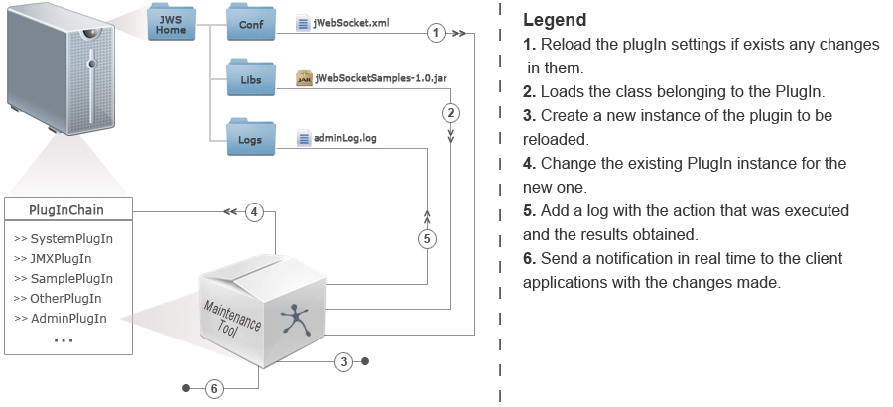
Fig. 1 Diagram with the actions executed for recharging plugins

Please provide the diagrams as external files and link them into this word document instead of embeddeding it!
JWebSocket Management Desk also has features that allow you to alter the priority order of the plug-ins and filters in the chain of responsibility of jWebSocket server, thus ensuring higher performance (why that? if you allege that, you should give at least an example) and its proper operation. All the functionalities described above send a real-time notification of the changes to all client applications currently connected. This fact allows developers to take immediate decisions taking into account the changes made. jWebSocket Management Desk tool also carries out a logs record in which is kept the constancy of all actions performed on the server and the results obtained.
jWebSocket Management Desk is a secure application, authentication and credentials are needed to perform their functions, also the communication between client and server is done through the secure protocol “wss” (WebSocket Security). This tool also allows to remotely access its full functionality through JMX (Java Management Extensions). In this case the access is via RMI protocol (Remote Method Invocation) or HTTP protocol offering more flexibility and application control to administrators.
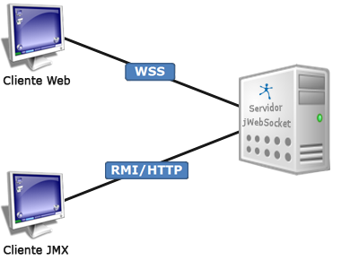
Fig. 2 Types of connections allowed between the client and server in jWebSocket Management Desk.
Can you provide the images separately? What tool did you use to create these?
Can you please provide the source files for that? E.g. to show english “server” instead of “servidor”. Thanks.
- Main Features
jWebSocket Management Desk tool provides the following functionalities:
- List all the plugins and filters that are loaded in the server at runtime.
- Load the new plugins or filters without restarting the services.
- Reload the plugins or filters.
- Delete the plugins and filters desired.
- Enable or disable the plugins or filters loaded.
- Change the order of the filter or plugins chain, thus optimizing the applications performance, again: How does the order of the plug-ins affect performance?
- Notify all the changes to the client applications connected to the server at the same time that are executed any of the actions described above. Thus allowing the client applications to know about the changes occurring on the server to ensure full integration.
- Record the trace of all the actions performed and the results thereof. This trace system can be configured as needed by the administrator.
3. Problems to be solved
Problem | Contributions of the solution
jWebSocket server does not have a tool or method that provides applications maintenance at runtime. This causes lack of availability during the maintenance process. | jWebSocket Management Desk allows you to dynamically update applications, either to make an improvement in the code or to correct a fault. With this the jWebSocket server solution can provide a high availability during the maintenance process.
Currently, jWebSocket server does not allow to make changes in the application settings without restarting the services. | With jWebSocket Management Desk the settings can be reloaded without restarting the services. It is only necessary reload the plugin or filter that has been changed.

4. Glossary
jWebSocket Framework: is a new technology aiming to develop WebSocket based applications that provide high levels of speed, scalability, security and real-time work.
WebSocket: technology that provides a bidirectional and full-duplex communication channel over a single TCP socket. This protocol solves the limitations of HTTP, by establishing a full-duplex communication (TCP) between the client and server, replacing the half-duplex communication (HTTP).
Full-Duplex: quality of the elements (what are “elements”, we are talking about Client/Server communication here, right?) that allow the input and output of data simultaneously.
Socket: method for communication between a client program and a server program on a network.
Half-Duplex: bidirectional, but not simultaneous, method or protocol for sending information. Please also mention request/response and the http limitation that only the client can request.
5. Solution Model
For a better understanding of how communication works within this application, you can see in Fig. 3. This diagram shows how the client web of the application through the WSS protocol communicates with the management plugin on the server. You can also observe that the connection can be made through a JMX client using RMI or HTTP protocols. The jWebSocket management plugin allows execute all the actions described above on any plugin or filter that is currently loaded.
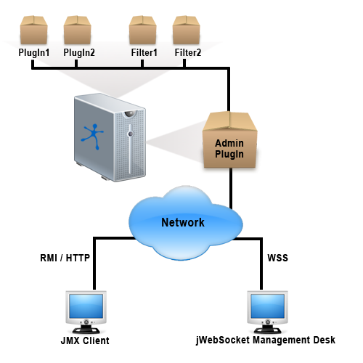
Fig. 3 Communication diagram of jWebSocket Management Desk tool.

6. Use Requirements
Please move installation and configuration to the Administrator Guide, this is not part of the user documentation.
To install the jWebSocket Management Desk application you should proceed to download the jWebSocket server and client packages (Table 1). jWebSocket Management Desk is included in these packages.
Below in the Table 1, you can see the links containing the installation manuals of the jWebSocket server and client. In this URLs are also the links to download these packages.

Package | Size | Link
jWebSocket Server | 12.4 MB | http://enapso.com/?q=node/156
jWebSocket Client | 13.6 MB | http://enapso.com/?q=node/161

It should also be considered as requirements for use, the following aspects:
- OpenJDK 7 or higher installed on the server. Does it work witj JDK 1.6 or JDK 1.7 as well. Should not be limited to OpenJDK 1.7.
- A browser that supports WebSocket on the client.

7. Solution Roles
The application is safe; it has an authentication system with user and password. By default when it is installed brings an "admin" user with the password "admin" and the credentials to access to the application.
ROLE_ADMIN_MAINTENANCE: role or credential needed to access to the application. Please refer ho to set this up in the Administrator Guide.

8. Operation of the system
This section will describe step by step how to execute each one of the application functions.
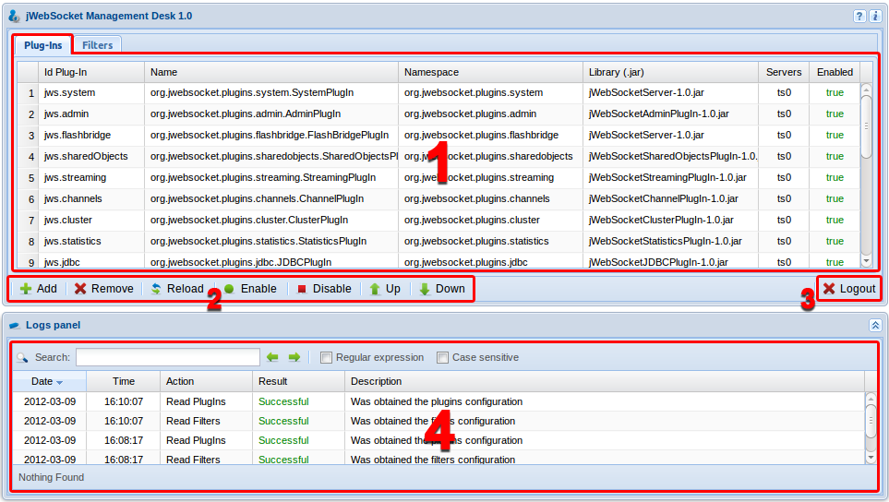
Fig. 4 Main View of jWebSocket Management Desk tool.

- Section that contains the lists of plugins that are running on the server, each one are described by several properties.
- Id Plugin: Unique identifier for the plugin. Coming from the config, please mention.
- Name: Packet address and name of the java class that represents the plugin.
- Namespace: Plugin scope. Mention that all plug-ins have their own name space to uniquely address them.
- Library: Java library name containing the plugin.
- Server: Name of the server where the plugin is running.
- Enabled: Boolean field indicating whether the plugin is active or not.
- Features bar for the maintenance and management of the plugins and filters.
- Button to close the application successfully and return to the authentication panel. Are potential changes saved automatically?
- This section lists the traces of the application. Esta sección contiene la lista de las trazas de la aplicación. <= Please translate to english or remove. These records all actions performed, giving to the user some relevant data from each one described below.
  - Date: Date when the action was executed.
  - Time: Execution hour.
  - Action: Functionality that was executed.
  - Result: Execution result, indicating if it was successful or failed.
  - Description: Response message from the server, either successful or failed.

Now will be described step by step each one of the features shown in the bar (2) described above.
Add Button → This button allows you to add a plugin or filter, depending on which tab is selected. In the event that the plugins tab is selected then a new window is displayed as described below.
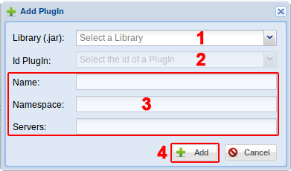
Fig. 5 Window that allows you to add a plugin.

As shown in Fig. 5 the first step is to select the library where the plugin will be loaded. To load the desired library, prior it has to be placed in the folder "libs" of the jWebSocket folder structure, (what about the spring config for a plug-in, you should mention that here, since it is required to start/use a plug-in.) for more information you can access to the Folder Structure section. The next step is to select the id of the plugin, on the drop-down list (2) will show up the identifiers of the plugins that are contained in that library, see Fig 6. However, for the application to recognize the plugins which are associated with the selected library first is necessary to insert these plugin settings in the file "jWebSocket.xml".
By the way: reloading a plug-in does consider changes in the spring configuration? This might be very interesting since, changing options in the spring comfit will be a highly demanded feature :-)
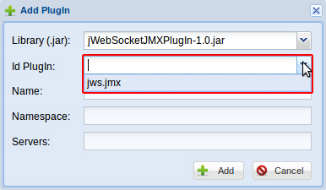
Fig. 6 Shows how to select the Id of the plugin that you want to add.
After selecting the plugin that you want to add, the section marked as (3), see Fig. 5, will provide the remaining information of the plugin. In this way the user can confirm that the selected plugin is the desired one, see Fig. 7.
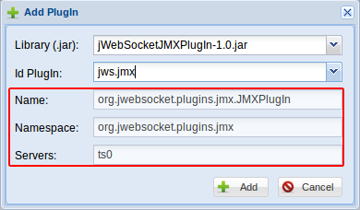
Fig. 7 Displays the remaining properties of the selected plugin.

After selecting the plugin then you can press the add button (4), see Fig. 5, this button will rise up a new window asking to the user the reasons of why he want to add this new plugin to an application. It should be added that such information will be sent to client applications if the change is satisfactory, so customers can synchronize it with the changes on the server and also to know what the reasons for change was, see Fig. 8.

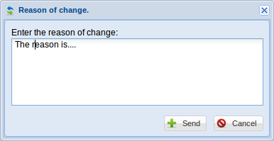
Fig. 8 Window to enter the reasons of the changes that you want made.

Finally, after introducing the reasons of the change, you must press the button "send" so the information will be sent to the server and it will be processed by it.

Delete Button → This button allows you to remove the plugin or filter selected. Must be selected earlier from the list of plugins or filters, the component you want to delete. This plugin or filter will be completely removed from the server and from the settings as well. This means that on a next server start it won’t be loaded again as well. However, these settings are stored in a temporary file. In this way, if the user wants to restore a plugin or filter previously deleted does not need to insert again the same settings in "jWebSocket.xml", can simply proceed to add it. In these cases the application will access to the temporary file mentioned above and reset the settings of the plugin or filter.

Reload Button → This button allows you to reload a plugin or filter selected from the list of loaded plugins or filters on the server. This option allows you to recharge again the settings (also from the spring configuration file?) of the selected item and in turn creates a new instance of it using the updated library with the new plugin code. Keep in mind that the first step is to update the Java library that contains the code changes. The second step is to review and change the settings of the plugin or filter in the "jWebSocket.xml" file if is necessary. Finally we proceed to reload the plugin or filter to which you must enter the reasons for the change, see Fig. 8.
If you want to load a new version of a plugin or filter and change the name of the library to which it belongs, first you must copy the new library in the "libs" folder on jWebSocket folder structure. Finally, you must change in the settings of the plugin or filter the content of the label "<jar>" specifying the new name of the library. After making these changes you can proceed to reload the plugin or filter in it new version.

Enable Button → This button activates a plugin or filter when is off, selecting it from the list of plugins or filters. The plugins and filters disabled remains instantiated on the server. So when a plugin is enabled there is no need to load its settings again or create a new instance of it. If you want activate the plugin or filter with certain change you must proceed first to recharge it. To activate a plugin or filter you should select it, click on "Enable" button and finally enter the reasons of the change, see Fig. 8.

Disable Button → This button allows you to disable a plugin or filter that is activated by selecting it from the list of plugins or filters. This option disables the plugin or filter on the server, so from that point on this component will not process any new request arrives to the server. To disable a plugin or filter you should select it, press the "Disable" button and finally enter the reasons of the change, see Fig. 8.

Up and Down Button → The function of these buttons is to sort the chain of plugins or filters in the jWebSocket server. The proper functioning of the server largely depends on a proper order of the filters loaded therein. Moreover, since each time that a request comes in it has to be served by each plugin in the order that they are found, the fact of organizing the plugins considering the one which most request received, allows reducing the response times and increase the server performance. I understand that the order of the filters can have a significant effect on the performance, but please explain in one sentence why. In order to execute these actions you should select the plugin or filter that you want to move either up or down as appropriate. Is all that thread safe in the implementation, how?

9. Solution Settings

9.1 Default User Settings
The application has a configurable authentication module. By default is defined the user "admin", with a password "admin" which allows access to the application without making any changes to the settings.
  - Modify Default User
This is part of the Administrator Guide.
If you want modify the authentication module configuration, you must access the folder that contains the jWebSocket server settings. In the settings edit the file "system.xml" located in the folder "SystemPlugIn". This file contains the following default settings:
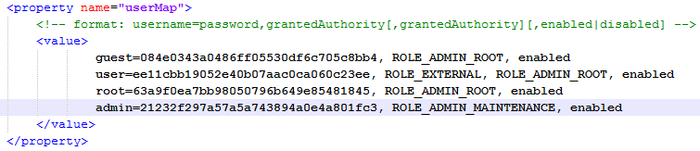
Note: for more information about the folder structure of the server, you can access to Folder Structure section.

To change the "admin" user you should consider the following aspects:
- The password must be encrypted with MD5.
- The credentials required for access to the application is "ROLE_ADMIN_MAINTENANCE".
- The user must be active for the authentication to work correctly.

  - Add new user
This is also part of the Administator Guide not the User Guide!
To add a new user to the authentication module you must access to the settings file mentioned above and add a new line with the desired values. For example, if you want to add an "administrator" user with the "ROLE_ADMIN_ROOT" and "ROLE_ADMIN_MAINTENANCE" credentials the configuration file looks as follows:
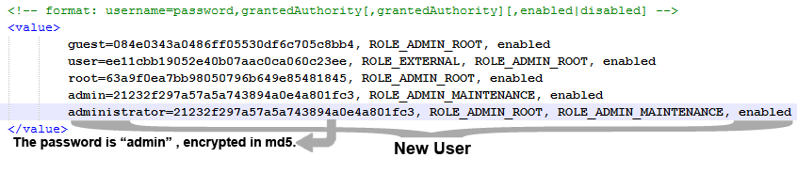
  - Configure the trace
Please move all configuration to the Administrator Guide.
The traces or records of actions executed by the application are stored in a log file. jWebSocket Management Desk allows you to configure how many days back you want to show you the traces. The default number is 30 days.
If you wish to change this default value, you can access to the jWebSocket main configuration file named “jWebSocket.xml”, search the plugin configurations whose identifier is "jws.admin "and change the value of property "numberOfDays" by the desired value.
For example, if you want to change the number of days to 10, the configurations would be as follows:
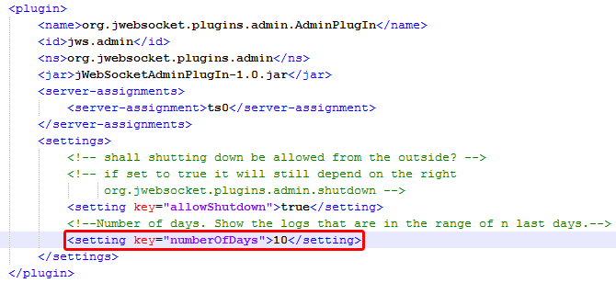

10. Solution Rules
R1: Authentication of the application failed. This may occur for several reasons, first and most common is for introduce the wrong username or password, so you need to try again and being careful to not make mistakes. The second reason may be that the user who is entering does not exist or does not have the necessary credentials to enter. In this case the solution is to verify the configuration file where the user’s settings are stored. If this were not enough you need to verify that the server is operating properly, specifically the plugin called "SystemPlugIn" that is responsible for authentication.

R2: If you try to add a plugin or filter and the specified library or plugin contains no new filter displays the following error “AdminPlugInService on getPlugInsByJar: Can't found any plugin in the jar 'LibraryName.jar' ” and the system does not continue with the normal flow of events. To solve this problem first you must verify that you have copied the correct library. In the event that the Java library is correct then make sure that the filter or plugin to be loaded does not have an id equal to one who is already loaded, because in this case it invalidates the load of the new plugin or filter. Finally you can check in the plugin settings if matches the name of the library located on the label <jar> with the name of the library copied in the "libs" folder.

R3: Error occurred during configuration update, “The settings don't refresh”. One of the reasons why this error is shown is when the "jWebSocket.xml" configuration file is damaged or has been deleted. Check these configurations file and if the problem will continue try to reload the "jws.admin" plugin. In case the problem continues contact with the product developers.

R4: If you try to add or reload a plugin or filter and the specified library is incorrect or does not exist in the "libs" folder of jWebSocket, the system throws the following error “Couldn't loading filter 'org.jwebsocket.filters.custom.CustomTokenFilter' from 'null' ” and it does not continue with the normal flow of events (only for that plug-in or for all plug-ins)? This error should not crash the server, please explain a bit more in detail. The solution is to verify that the plugin or filter selected has correctly defined the name of the library from it must be loaded. If the problem persists, check that the library is in the "libs" folder of jWebSocket. What happens if the plug-in can not be loaded in case of config issues in its spring comfit?

R5: When you try to change the order of the plugins or filter the system throws following error “This action cannot be made, is invalid” and it does not continue with the normal flow of events (same like above: does this mean “crash the server” ? Please explain. This error is produced because you are doing an invalid action, namely trying to up the first item in the list or trying to down a step on the last item in the list. Make sure that you have selected the plugin or filter that you want, and the movement is valid.

R6: The application does not respond. Verify that the error is not produced because it was accidentally deleted the "jws.admin" or "jws.system" plugin. These plugins are essential for the proper functioning of the application. If the problem persists, contact the product developers.

